My website is going to be a site focusing on a portfolio on some of my previous work, and the skills I have including an online CV.

When designing a website I prefer to use Photoshop for my designs as well as a greyscale design of the layout of the pages. I have included a design of what content will be placed where as well as a detailed design of the header, navigation and footer and a navigation list. All of my designs can be found inside my GitHub folder as well as screenshots placed inside of this document.

**Initial Designs**

Mt website will be responsive therefore there will be designs for the mobile device as well as desktop, there will be no designs for a tablet as this works with the desktop design.

Header & Navigation design

Below is my header design for the desktop. This design will be consistent throughout all of the pages in this website, there will be no change apart from maybe the page that will be open may have a active design like bold text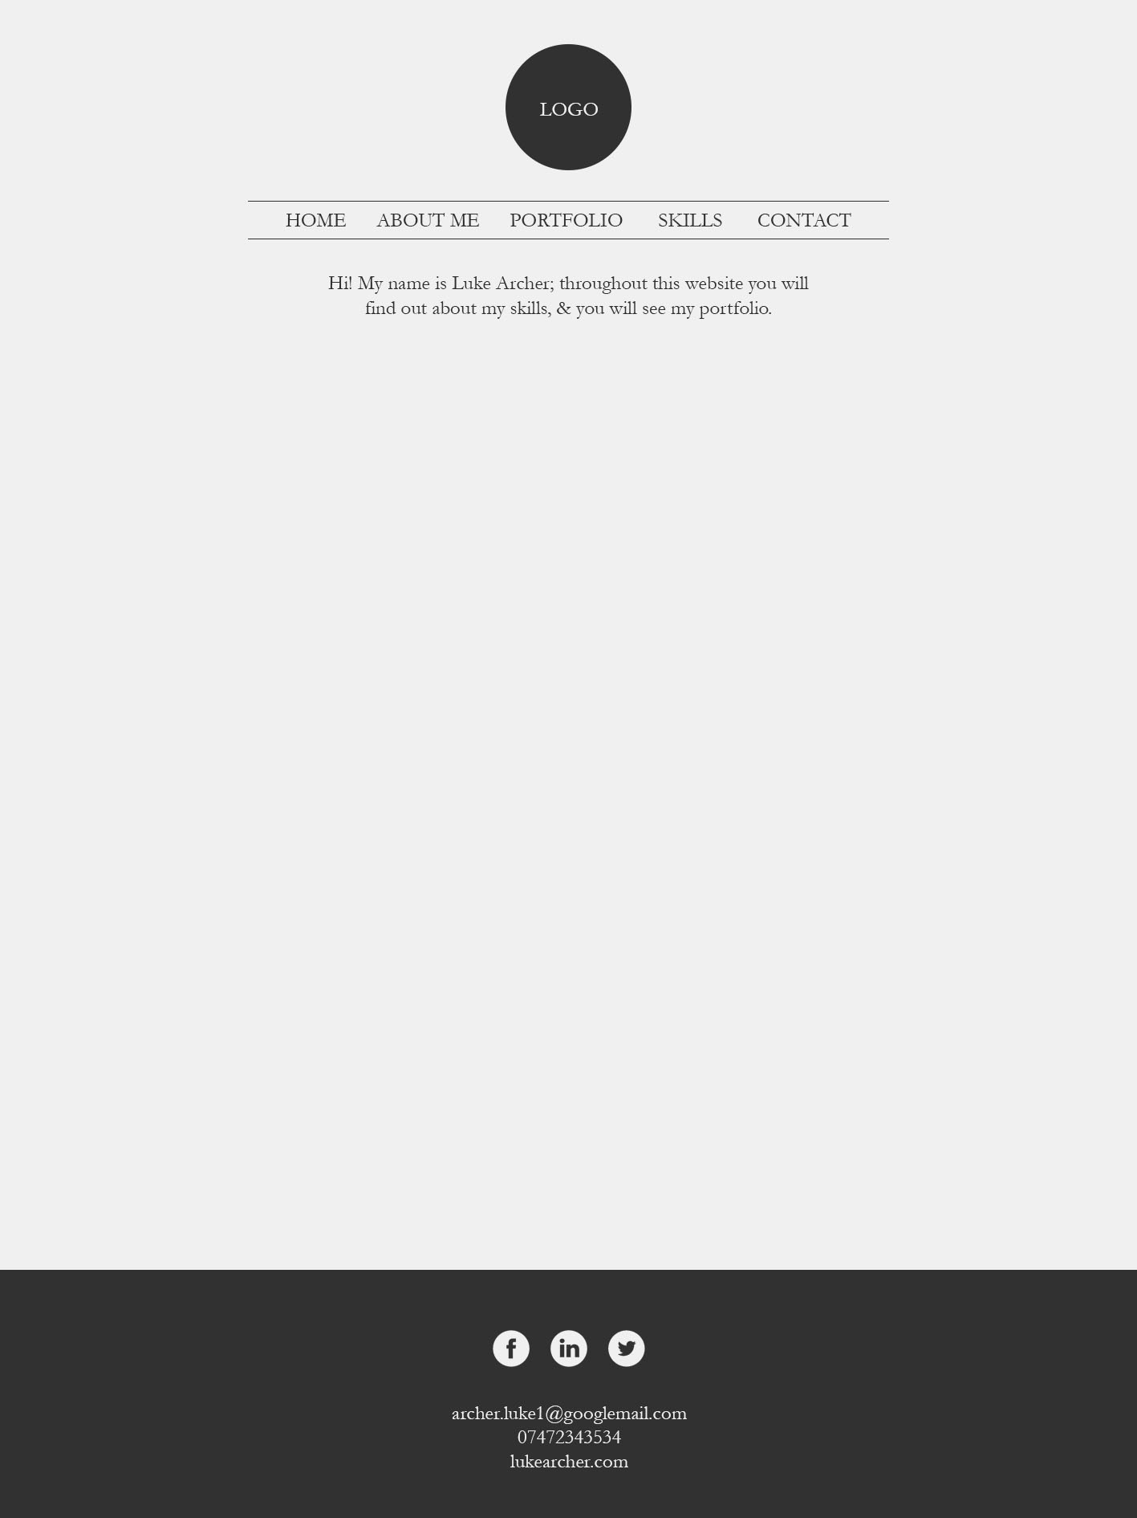

Below is my header design for my responsive mobile screen. The navigation will only be visible when the icon is pressed and will close when the same icon is pressed.

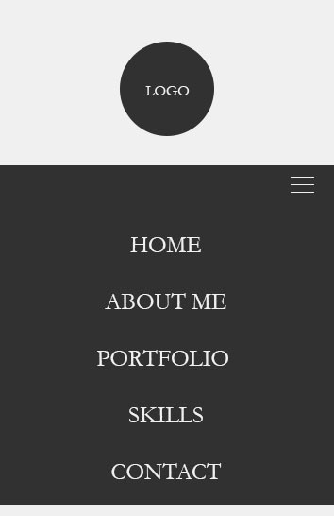

Footer design

The footer design will also be a consistent style throughout all of the pages created in this website, the footer is a great way to add quick links which you do not want in the navigation bar, as my website is small with few pages I will only add social links and contact information.

Below is the design for the desktop and the mobile design, there is no difference in design with any size screen of information changed, I will use percentage design and ems to style the footer so I do not need to use any @media queries.

Desktop design for footer



Mobile design for footer

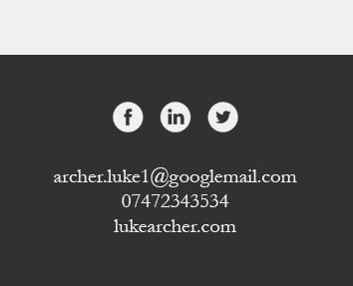

Pages created

I will be creating a website which consists of 5 pages, these are

* Home
* About me
* Portfolio
* Skills
* Contact

Each page as stated before has the same header and footer and navigation, only the content in the sections will be different as well as some JavaScript to showcase my skills which I will mention later. I have created further designs which are paper based and content for the website which have been condensed to keep this document short, therefore all of the designs have been created on the desktop to keep the document short and focused on the website. The photos of the paper based designs can be found in my Github folder.

I have attached my navigation plan below.

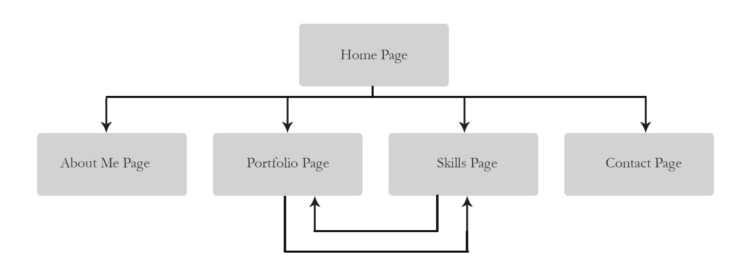

Greyscale layout of page content

I have created a layout of the page content in Photoshop to help me focus on how I want information to be portrayed to the users, I have used rectangles and squares to show where items will go however my final design will be considerably different. Below I have attached the images of my greyscale designs.

Home page layout Desktop and Mobile below

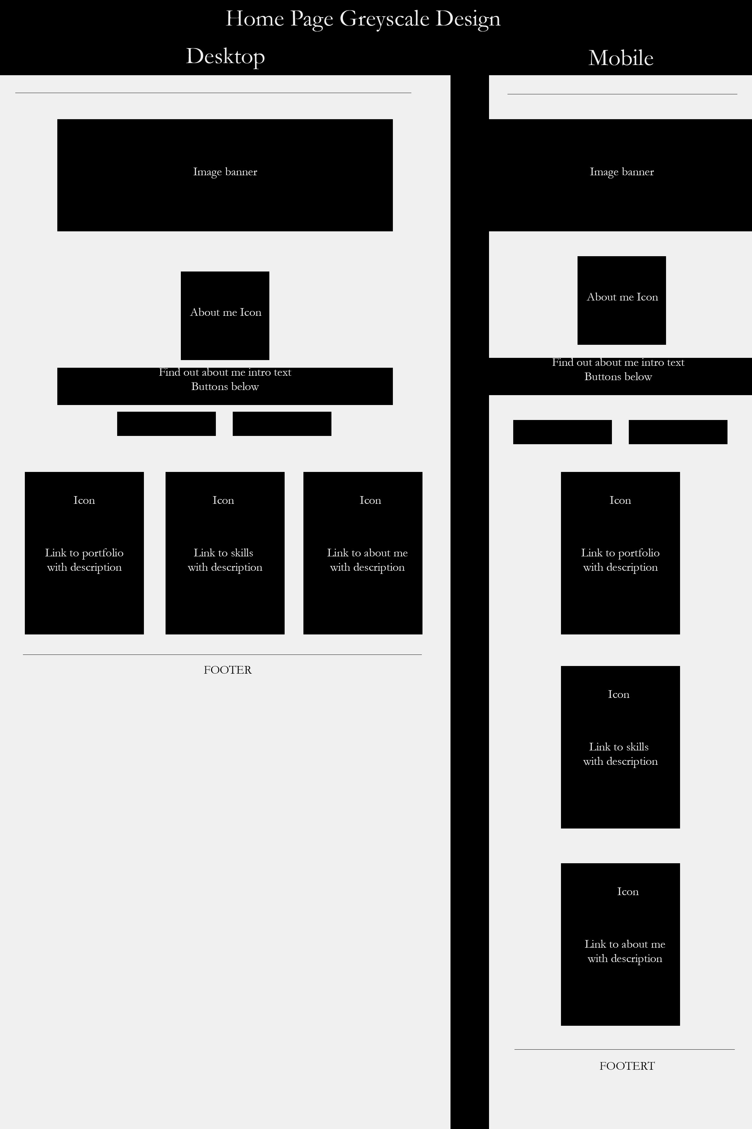

About me page layout Desktop and Mobile

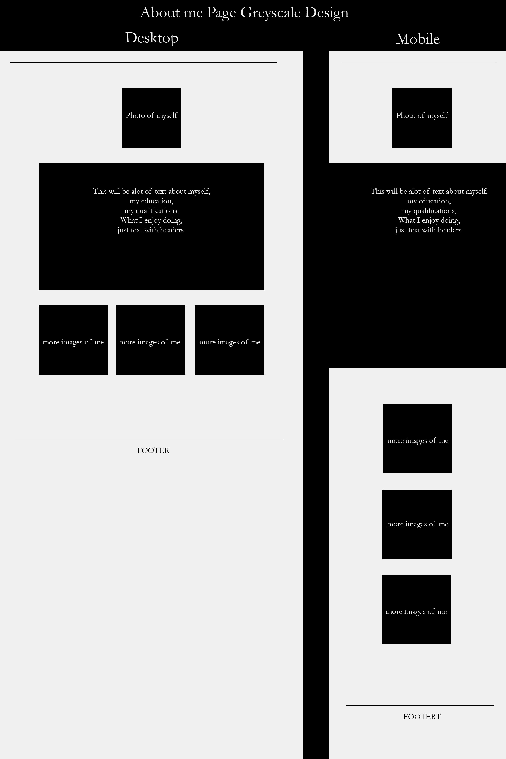

Portfolio page layout Desktop and Mobile

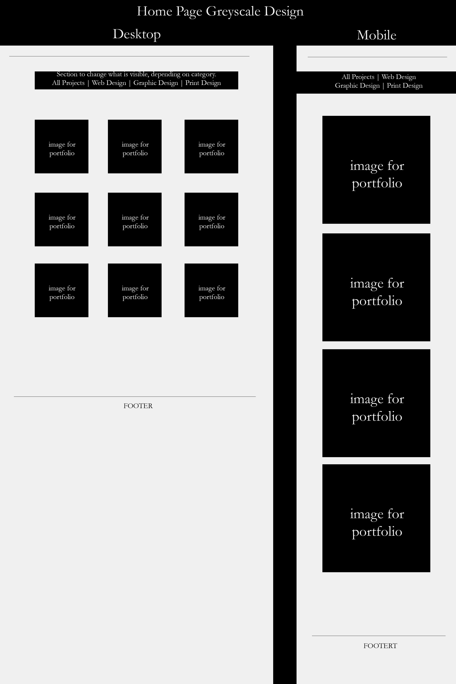

Skills page layout Desktop and Mobile

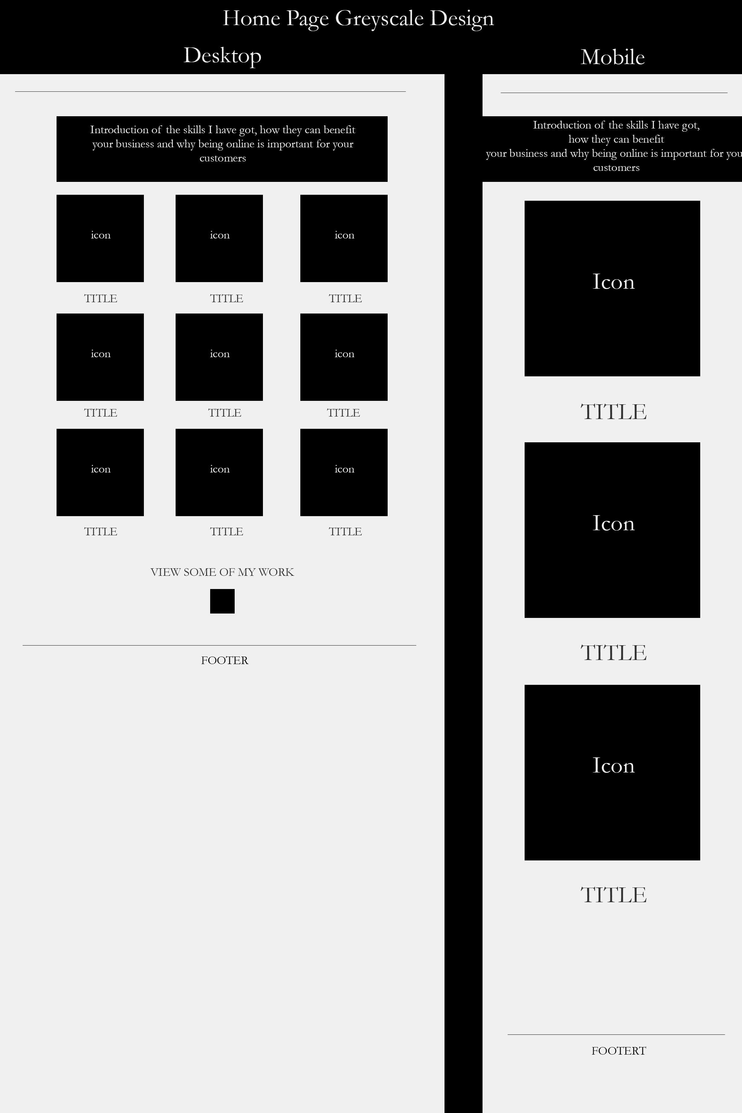

Contact page layout Desktop and Mobile

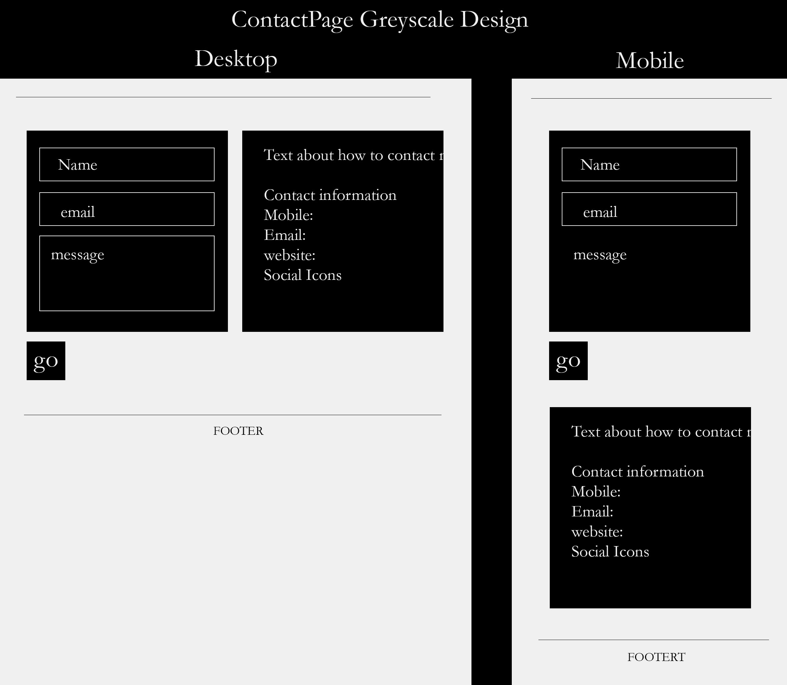

Prototype Screenshots

All of my final designs have been designed using Photoshop, this is a great way for me to finalise my design and showcase how I want my final deliverable to be. I have only designed the desktop in final design as the mobile designs are exactly the same just played out differently as can be seen through the greyscale designs.

Home Page design

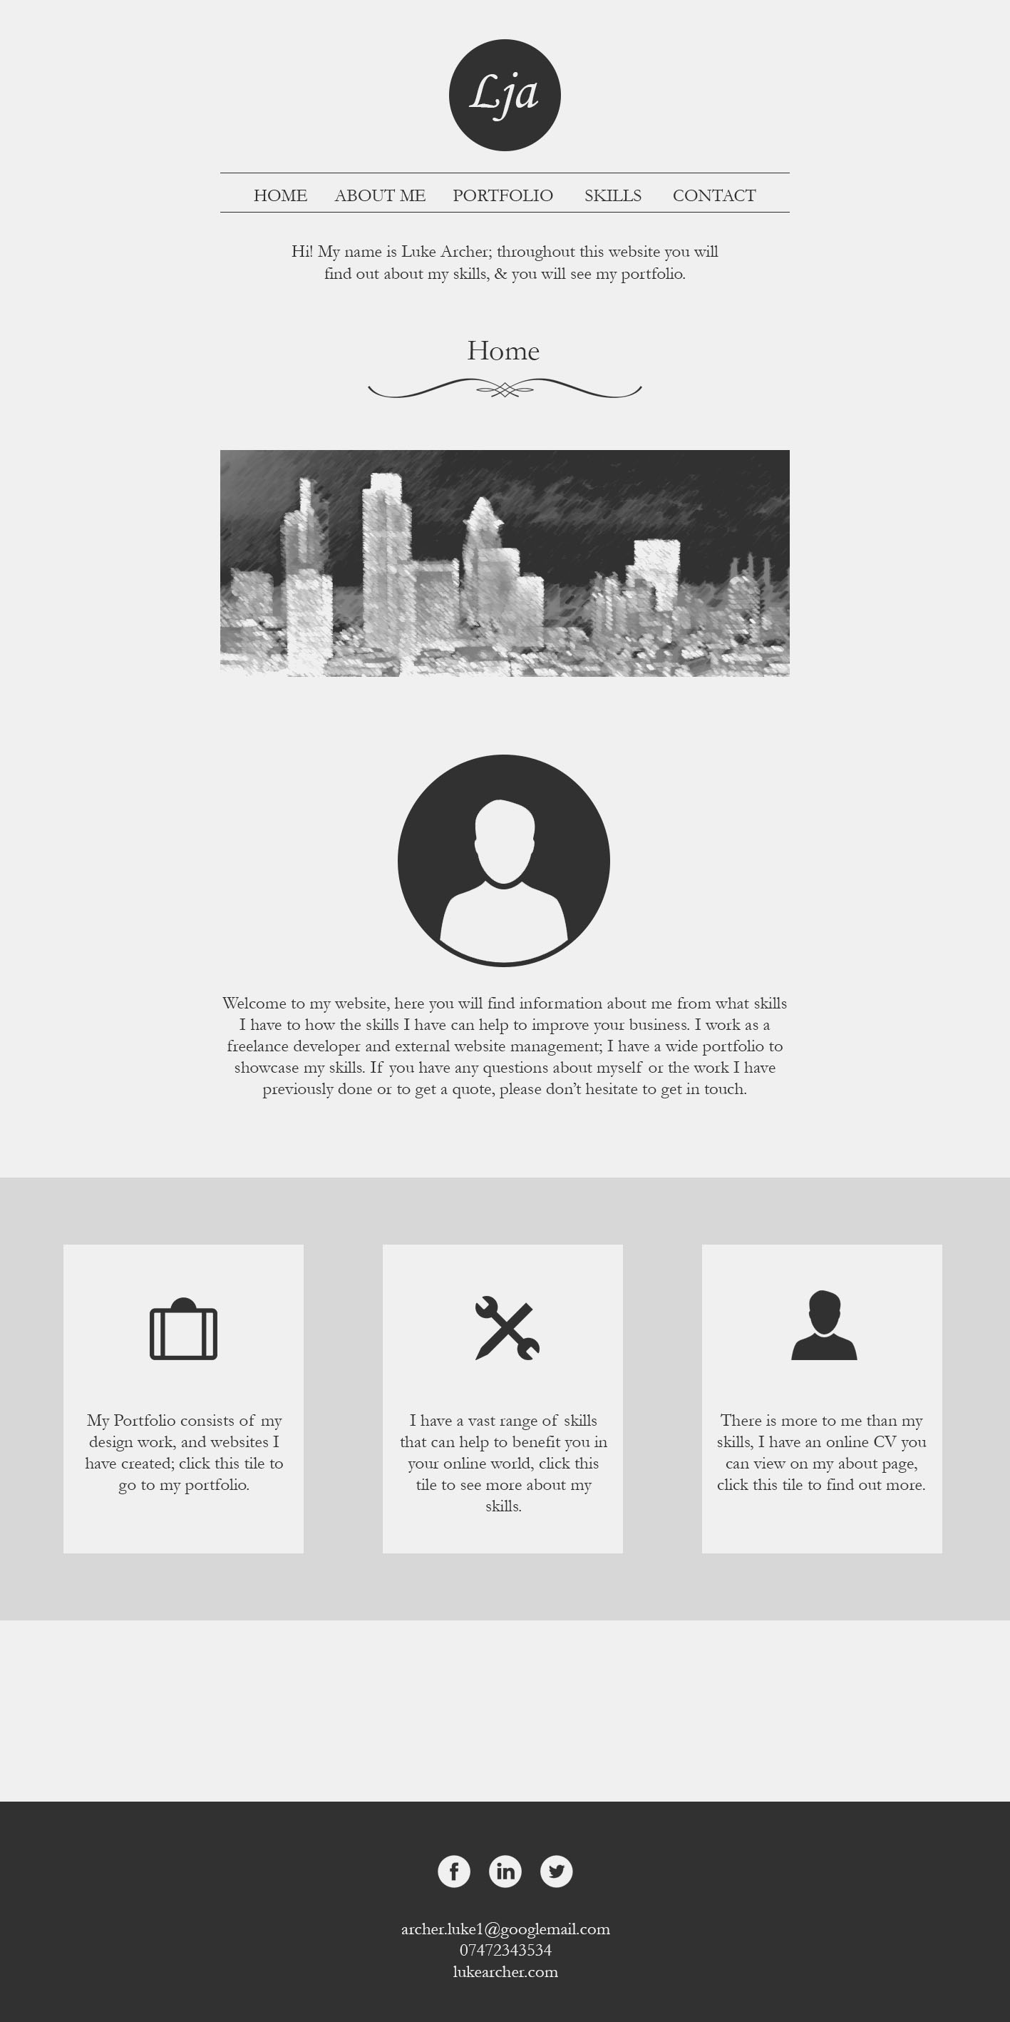

Portfolio Page Design

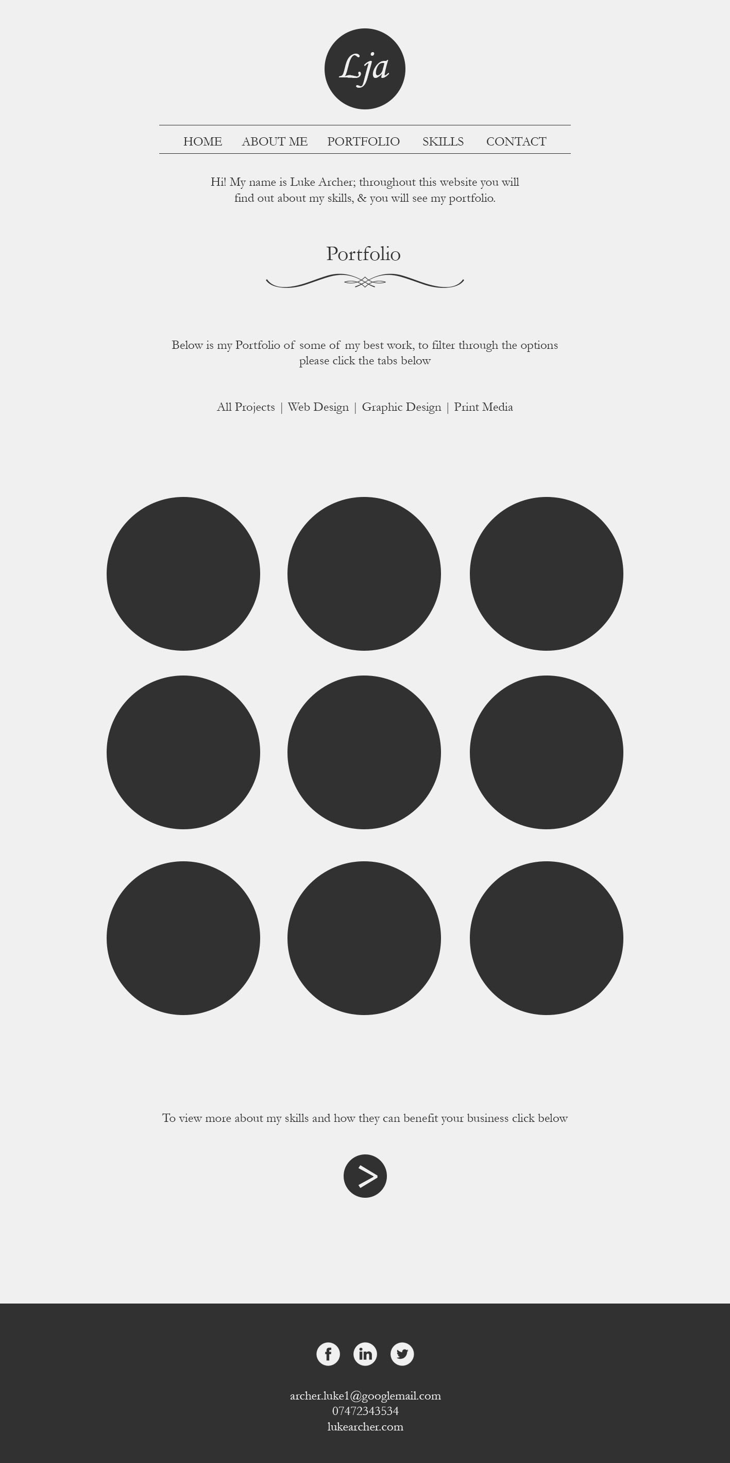

Skills Page Design

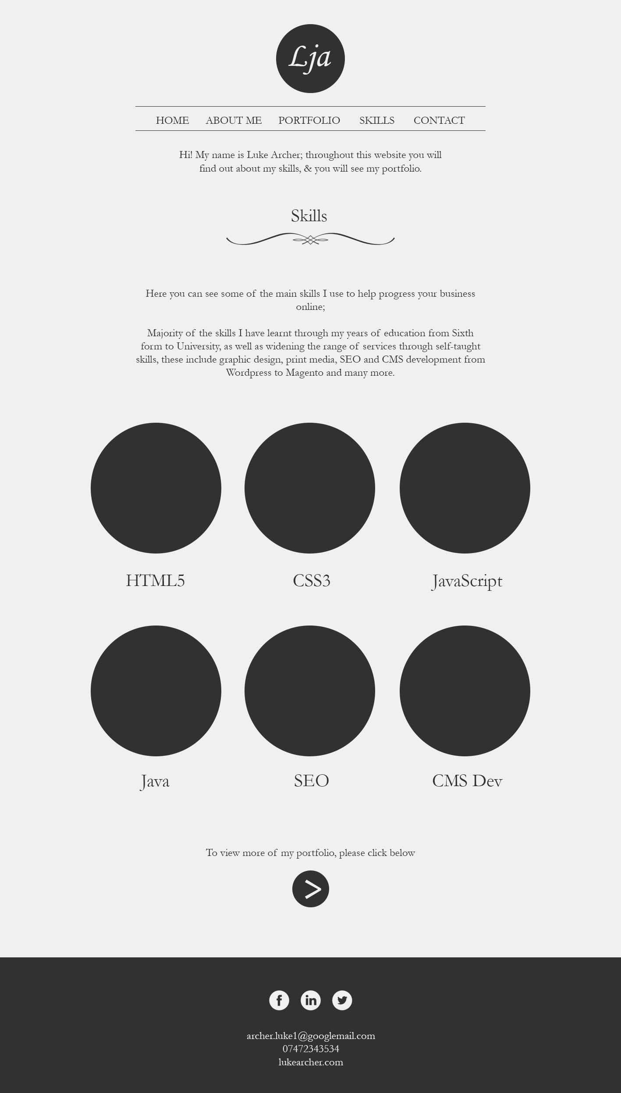

Contact Page Design

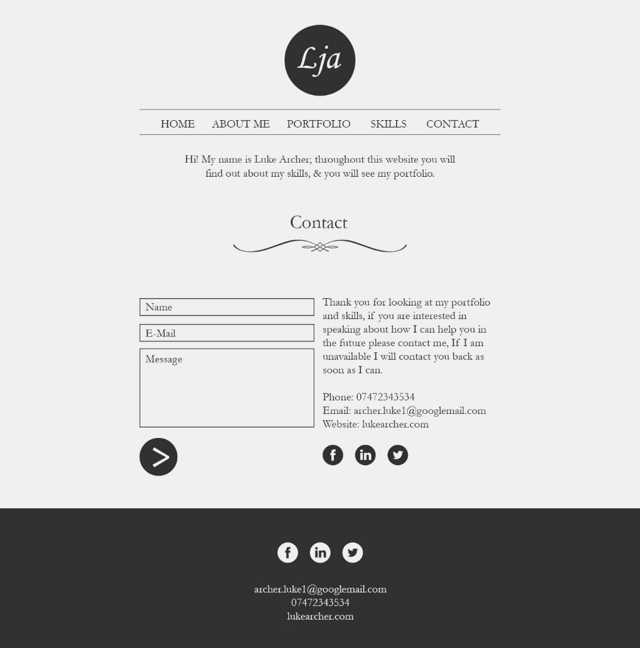

* Prototype screenshots, use Photoshop – need to do about me page, and one for mobile design
* Add all photos of design and paper based design to GitHub
* Add JavaScript designs and what they do